ECEN 350 – Extra Credit Fourier Series HW (16 points)
(jas, Extra Credit Fourier Series HW.docx, 12/09/2025)

All periodic waveforms can be represented as a sum of sinusoids of differing amplitude and frequency, referred to as a Fourier Series. The Fourier Series expansion for a (0 to 1) V square wave is given as follows:
$$x\left(t\right)=\left(1/2\right)+\sum_{n=1, 3, 5, 7,9,11}^{∞}{\frac{2}{nπ}sin\left[\left(n\right)2πft\right]. (Equation 1.)}$$

An infinite number of terms are required for an exact representation, whereas a reasonably good approximation can often be obtained with just a few terms, as demonstrated in this assignment.

Calculate the amplitude in volts and corresponding frequency, in Hz of the Fourier Series terms from Equation 1 for n = 1, 3, 5, 7, 9 and 11, for a fundamental frequency of f = 1 kHz. Enter your calculated values, including units, in Table 1 below.

Table 1: Amplitude and Frequencies of Fourier Series Expansion for a 1 kHz Square Wave.
n | Amplitude | Frequency
1 | 0.6366 V | 1000 Hz
3 | 0.2122 V | 3000 Hz
5 | 0.1273 V | 5000 Hz
7 | 0.0909 V | 7000 Hz
9 | 0.0707 V | 9000 Hz
11 | 0.0579 V | 11000 Hz

Next using a DC voltage source of 0.5 V for the ½ term in Equation 1, along with series AC voltage sources of the correct amplitude and frequencies for V1, V3, V5, V7 and V11, construct a circuit to generate an approximation to a square wave with the series connected voltage sources connected across a 10 kΩ load resistor, as shown below in Figure 1. Note: The AC voltage source symbol shown in Figure 1 can be found in the Misc folder in the parts library as the signal component. Consult the available LTspice Help as needed. Annotate your name on your schematic and replace Figure 1 below with your version, including your AC voltage source values for sources V1, V3, V5, V7 and V11.
(6 Points.)

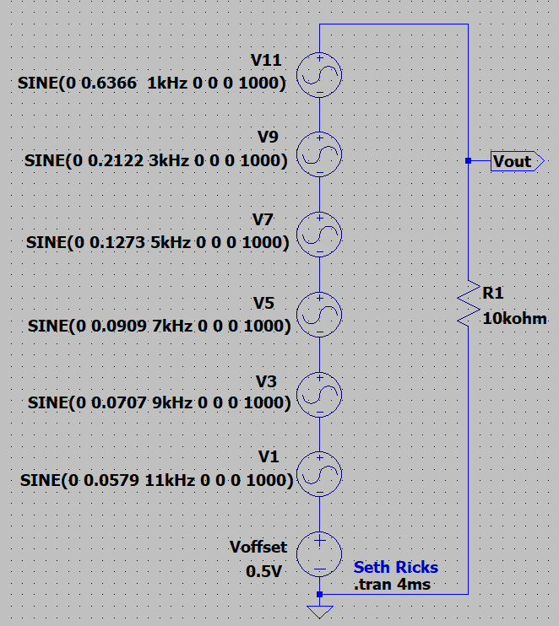
Figure 1: LTspice Circuit used to Simulate a Square Wave from Terms of the Fourier Series.

After completing your schematic, perform a transient analysis simulating with a stop time of 4 ms on your resulting circuit and select V(vout) in the plot pane. Your results should approximate a (0 to 1)V square wave like the image shown below in Figure 2, noting that the image below was resized in LTspice to increase the height relative to the width to make the waveform vertical scale easier to view. The LTspice Plot Pane includes two waveform cursors, both of which are to be attached to the V(vout) trace. Hover the mouse over the V(vout) expression near the top of the Plot Pane until the hand symbol appears. Then right mouse click to open an Expression Editor pane. The Attached Cursor box in that pane contains a pull-down menu that has a 1st & 2nd option, which attaches both waveform cursors to the selected trace. Attach both cursors to V(vout) and adjust the cursor horizontal locations by dragging the cursor cross hairs with the mouse or by means of the arrow keys on the keypad. Position the cursors to measure the largest peak-to-peak ringing associated with the approximation to a flat-topped square wave, as illustrated in the figure below. A cursor pane provides both horizontal and vertical cursor values, along with difference values between cursors for when both cursors are utilized, providing a measure of the non-ideal peak-to-peak ringing. The waveform below indicates a vertical difference between the two cursors of 138 mV, hence the maximum peak-to-peak ringing is approximately 138 mV for the square wave. Adding more Fourier series terms would result in less peak-to-peak ringing.

After adjusting the cursors to measure the maximum peak-to-peak ripple, drag the cursor box onto the plot pane so as to document your simulated values. Also annotate your plot pane with your name by means of the Plot Settings → Notes and Annotations → Place Text options available by accessing the Plot Settings pulldown menu above the toolbar. Replace the resulting plot pane below with your version. Note: You can adjust the aspect ratio of the Plot Pane in LTspice so that it is taller and narrower, as was done for the plot pane below. (10 Points.)
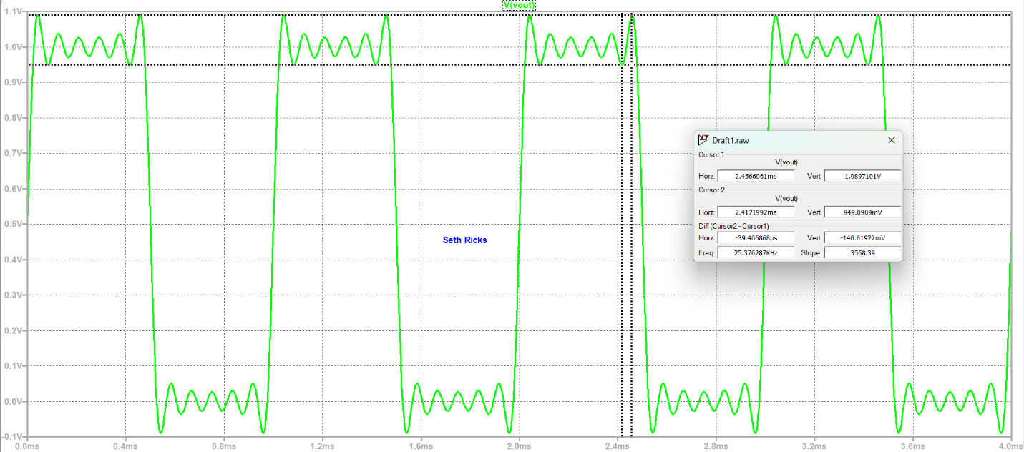
Figure 2: Square Wave Generated from Fourier Series Terms.

Maximum peak-to-peak ringing is ≈ 140 mV

